Metaphoric Expressions in Pictures about the State of Laos
Name of Student
Name of Institution
Date
The documentary named surviving the peace uses pictures to illustrate two contradictory objects based on a singular common character. The picture shows an old man sitting on a missile that has not yet detonated and a naked child playing with the same missile. The picture is set in a homestead full of grass just paces away from living homes. It also contains a woman farming a stone’s throw distance from the missile with a young boy just behind her, the picture means to convey how dangerous the way of life is in Laos where there is a semblance of peace from the war but the remnants of war make for a cautious or carefree way of life (Rohrbach, et al., 2013). The image chosen for this segment adds to the documentary’s purpose of seeking assistance in removal and clearing of the explosive material in Laos.
The main source of income for the residents is farming which is challenged mightily by the presence of explosive materials left during the war. The image conveys a farm which is the resident’s cultural main source of income. It also shows the poor living standards of the residents and the trees surrounding the habitat illustrate an area within a forest set aside for living and farming, which serves as the cultural identity of the Lao people. Lao is widely stereotyped as a wasteland after the war. The place was used by the militias as a disposal site for the explosives that were not dropped on Vietnam as the militants headed back since it was risky to land with the explosives. The image supports this stereotype cliché by exposing that the residents find the presence of an explosive as a normal livelihood sighting.
The image should have contained the effects of such explosives. This explosives have permanently maimed a lot and killed a lot more after the war and showing the effect of these explosives would’ve sent a clearer message.

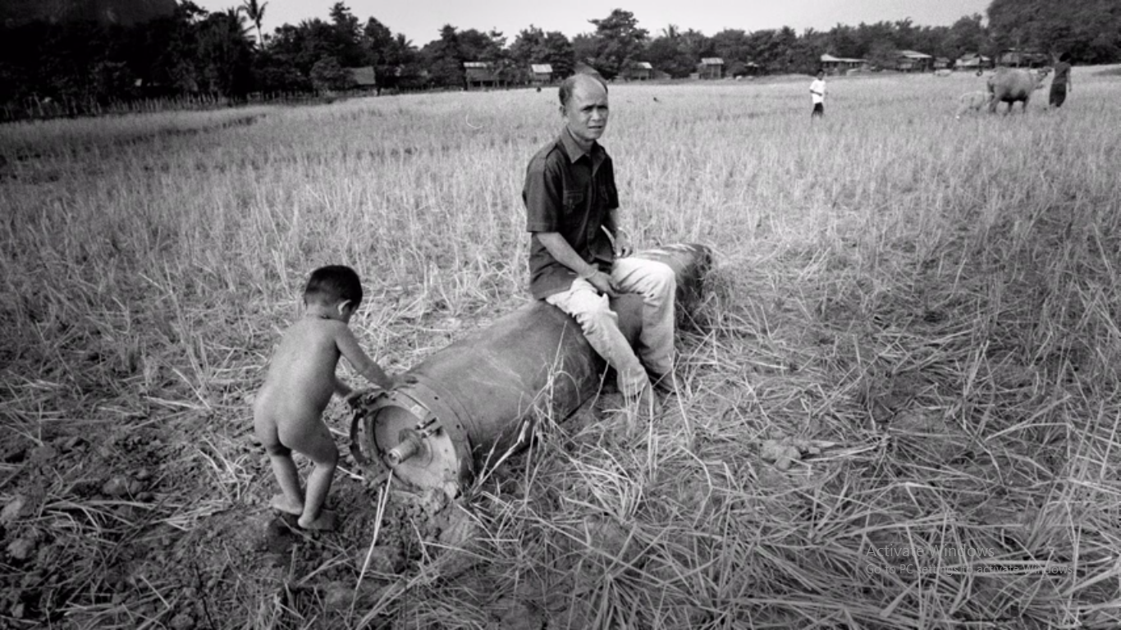

References
Rohrbach, M., Qiu, W., Titov, I., Thater, S., Pinkal, M., & Schiele, B. (2013). Translating video content to natural language descriptions. Proceedings of the IEEE International Conference on Computer Vision, 43-440.
https://www.youtube.com/watch?v=zWdrn7pOuSs

